Wanwen Tang
Professor Madeline Zehala
EAP II Section 8
2/6/2024
Project1 Final
Bridging Worlds: My Linguistic Odyssey
I was born in China and began to learn English and Spanish when I was young. In an English class in junior high school, when I first heard the saying "home is where the heart is", my language awareness was awakened. This simple yet profound maxim deeply moved me and resonated in my native China. It reminded me of an old Chinese saying my grandmother used to say, "Home is the harbor of the heart," and created a deep connection between my heritage and my new language exploration. This experience mirrored Nicholas Gage's transformation journey and subtly enhanced my understanding and appreciation of culture.
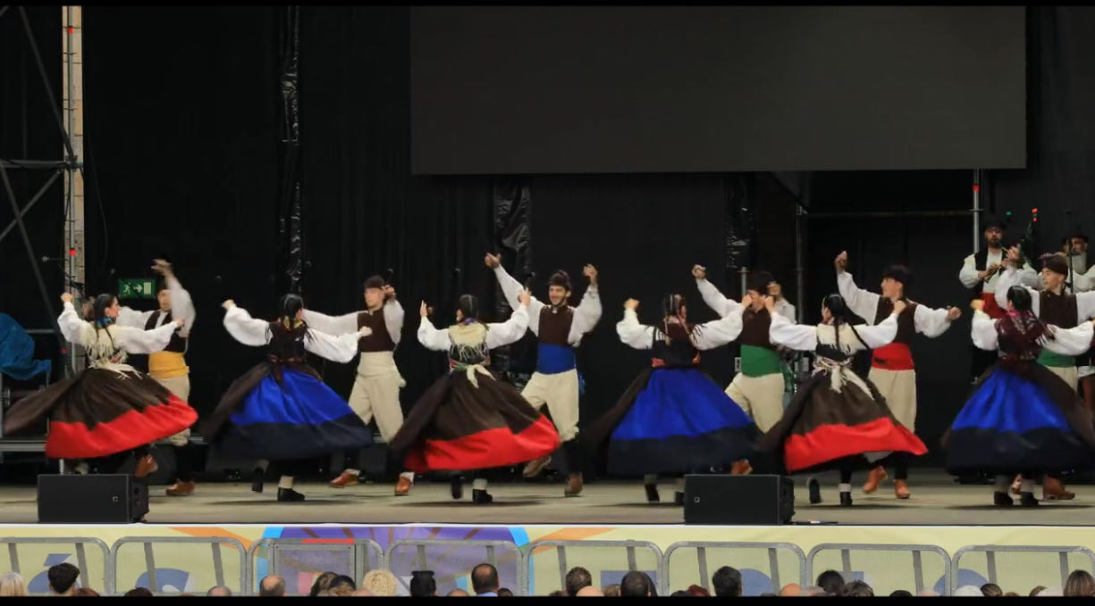
The transformative power of rites of passage in shaping personal development and cultural integration is a theme deeply explored in modern discussions, such as Dr. Blumenkranz's insights shared in the podcast "It Takes a Child to Raise a Village." In the podcast "It Takes a Child to Raise a Village," hosted by Diego Galli, Dr. Blumenkranz discusses the critical role of rites of passage in guiding young people through life transitions. Dr. Blumenkranz said, "without a path that is socially acceptable and of interest to young people, young people will try to initiate themselves through these behaviors that you care about" (Galli 02:52). This view resonates deeply with my own language journey, which I consider a personal rite of passage. Not only did it provide me with a way to reconnect with tradition, but it also provided me with a way to immerse and integrate myself into new cultures, thereby broadening my worldview and personal identity. For me, during a cultural exchange program in Spain, I found myself at a traditional festival, completely immersed in the local language and customs. Despite the initial language barrier, I gradually began to communicate effectively in Spanish, engaging in conversations and even partaking in local dances. This experience was more than just linguistic proficiency; it was a rite of passage where I transitioned from an outsider to an active participant in the community. I was not only learning a language but also embracing and living a culture, which significantly expanded my understanding of the culture and language.
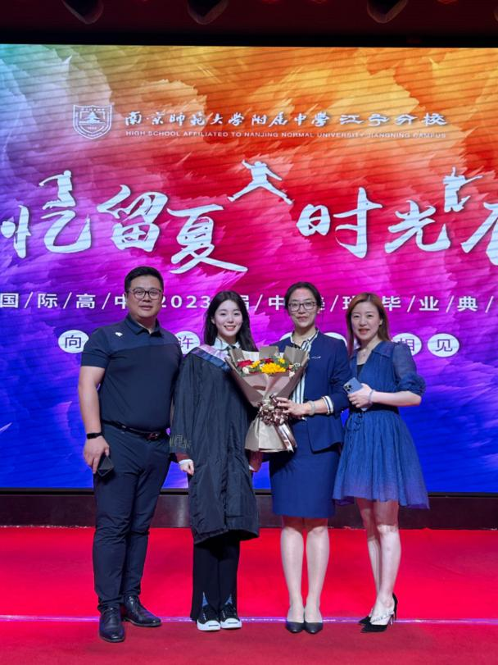

Parallel to the insights shared by Dr. Blumenkranz, Nicholas Gage's journey, under the mentorship of Miss Hurd, showcases the profound impact a mentor can have on a student's life, guiding them toward realizing their potential and embracing their heritage. Nicholas Gage's transformative journey under the mentorship of Miss Hurd exemplifies how impactful a teacher can be in guiding students towards realizing their potential and embracing their heritage. Gage writes about the life-altering impact Miss Hurd had on him, a young war refugee struggling with his past and painful experience of identity. She not only taught him the nuances of the English language, but also helped him translate his experiences with his family in Greece and the painful memory of saying goodbye to his mother for the last time into a powerful written narrative. This essay won the congratulations of the Worcester Greeks, and Gage eventually embarked on a literary path. Just as Dr. Blumenkrantz emphasizes the importance of a community-acknowledged pathway for youth, Gage's journey illustrates how a teacher's guidance can provide that critical direction. He notes, "She was the one who directed my grief and pain into writing, and if it weren't for her, I would not have become an investigative reporter and foreign correspondent" (Gage 90). This echoes my own experience, where language learning served as both my rite of passage and my mentor-led pathway to self-discovery and cultural integration. In my own life, a parallel experience occurred when my English language teacher encouraged me to participate in a national essay competition. Reluctant at first due to my self-doubt and language barriers, her persistent encouragement led me to write about my family's migration story. This essay not only won the competition but also marked a turning point in my self-perception. I am no longer afraid of writing and no longer mean to express myself in writing. The above photo is just me, my family and my English teacher at the award ceremony. Like Gage, who was inspired by Miss Hurd to channel his experiences into writing, I found a new voice through this exercise, gaining confidence in my identity and a deeper appreciation of my identity. Both experiences underscore the significance of mentorship and guidance in navigating the rites of passage, illustrating how it can serve as a beacon for personal growth and cultural understanding.
On reflection, the process of language learning, as I experienced with Nicholas Gage, is not just the acquisition of language skills; It becomes a channel for personal transformation and cultural integration. The words of Dr. Blumenkrantz, the guidance of teachers such as Miss Hurd, and my own language teachers played an important role in guiding me on my journey. They illuminated my path from a passive participant in a new culture to an active contributor though writing, blending my rich Chinese heritage with the different nuances of Western culture. This language journey is not just about crossing language barriers; It is a deeper exploration of identity, heritage and belonging. Like Gage, who channeled his grief into a celebrated writing career, my experiences with language shaped my narrative, turning challenges into opportunities for growth and self-expression.

